State Transition Diagrams:

1) Object:EMPLOYEE ACCOUNT

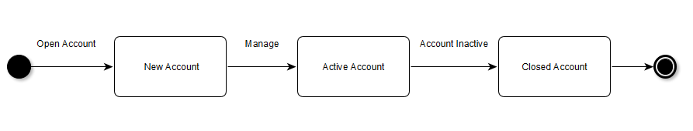

2) Object:ATTENDANCE

C:\Users\student\Downloads\wqerr.png

3) Object:APPLICANT LIST

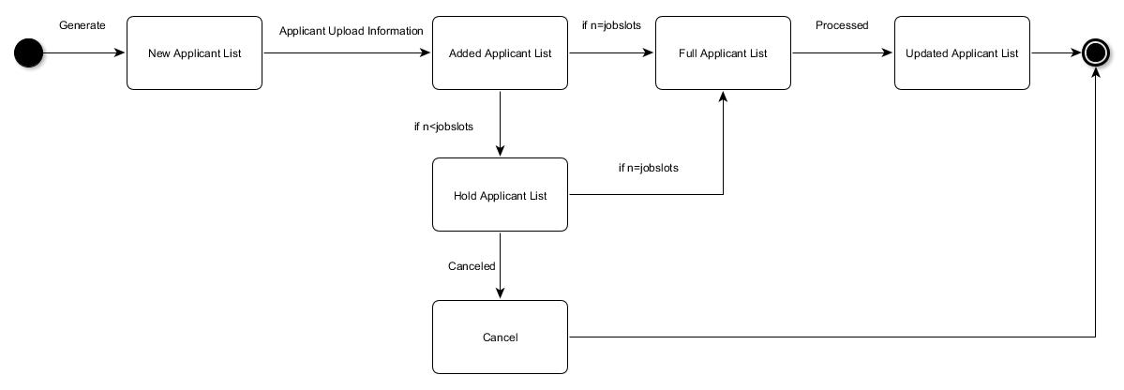

4) Object: PAYSLIP

C:\Users\student\Downloads\qweqw.png

5) OBJECT: JOB

C:\Users\student\Downloads\Untitled Diagram.png

6) OBJECT: EMPLOYEE DETAILS

C:\Users\student\Downloads\State-Chart Diagram (Employee Details).png